

Lab Report - 02

Course No: 206

Course Title: Digital Logic Design

**Submitted To:**

Iffat Tamanna

Dept: CSE

**Submitted By:**

Md: Zobayer Hasan Nayem

Id: 19202103274

Section: 07

Dept: CSE

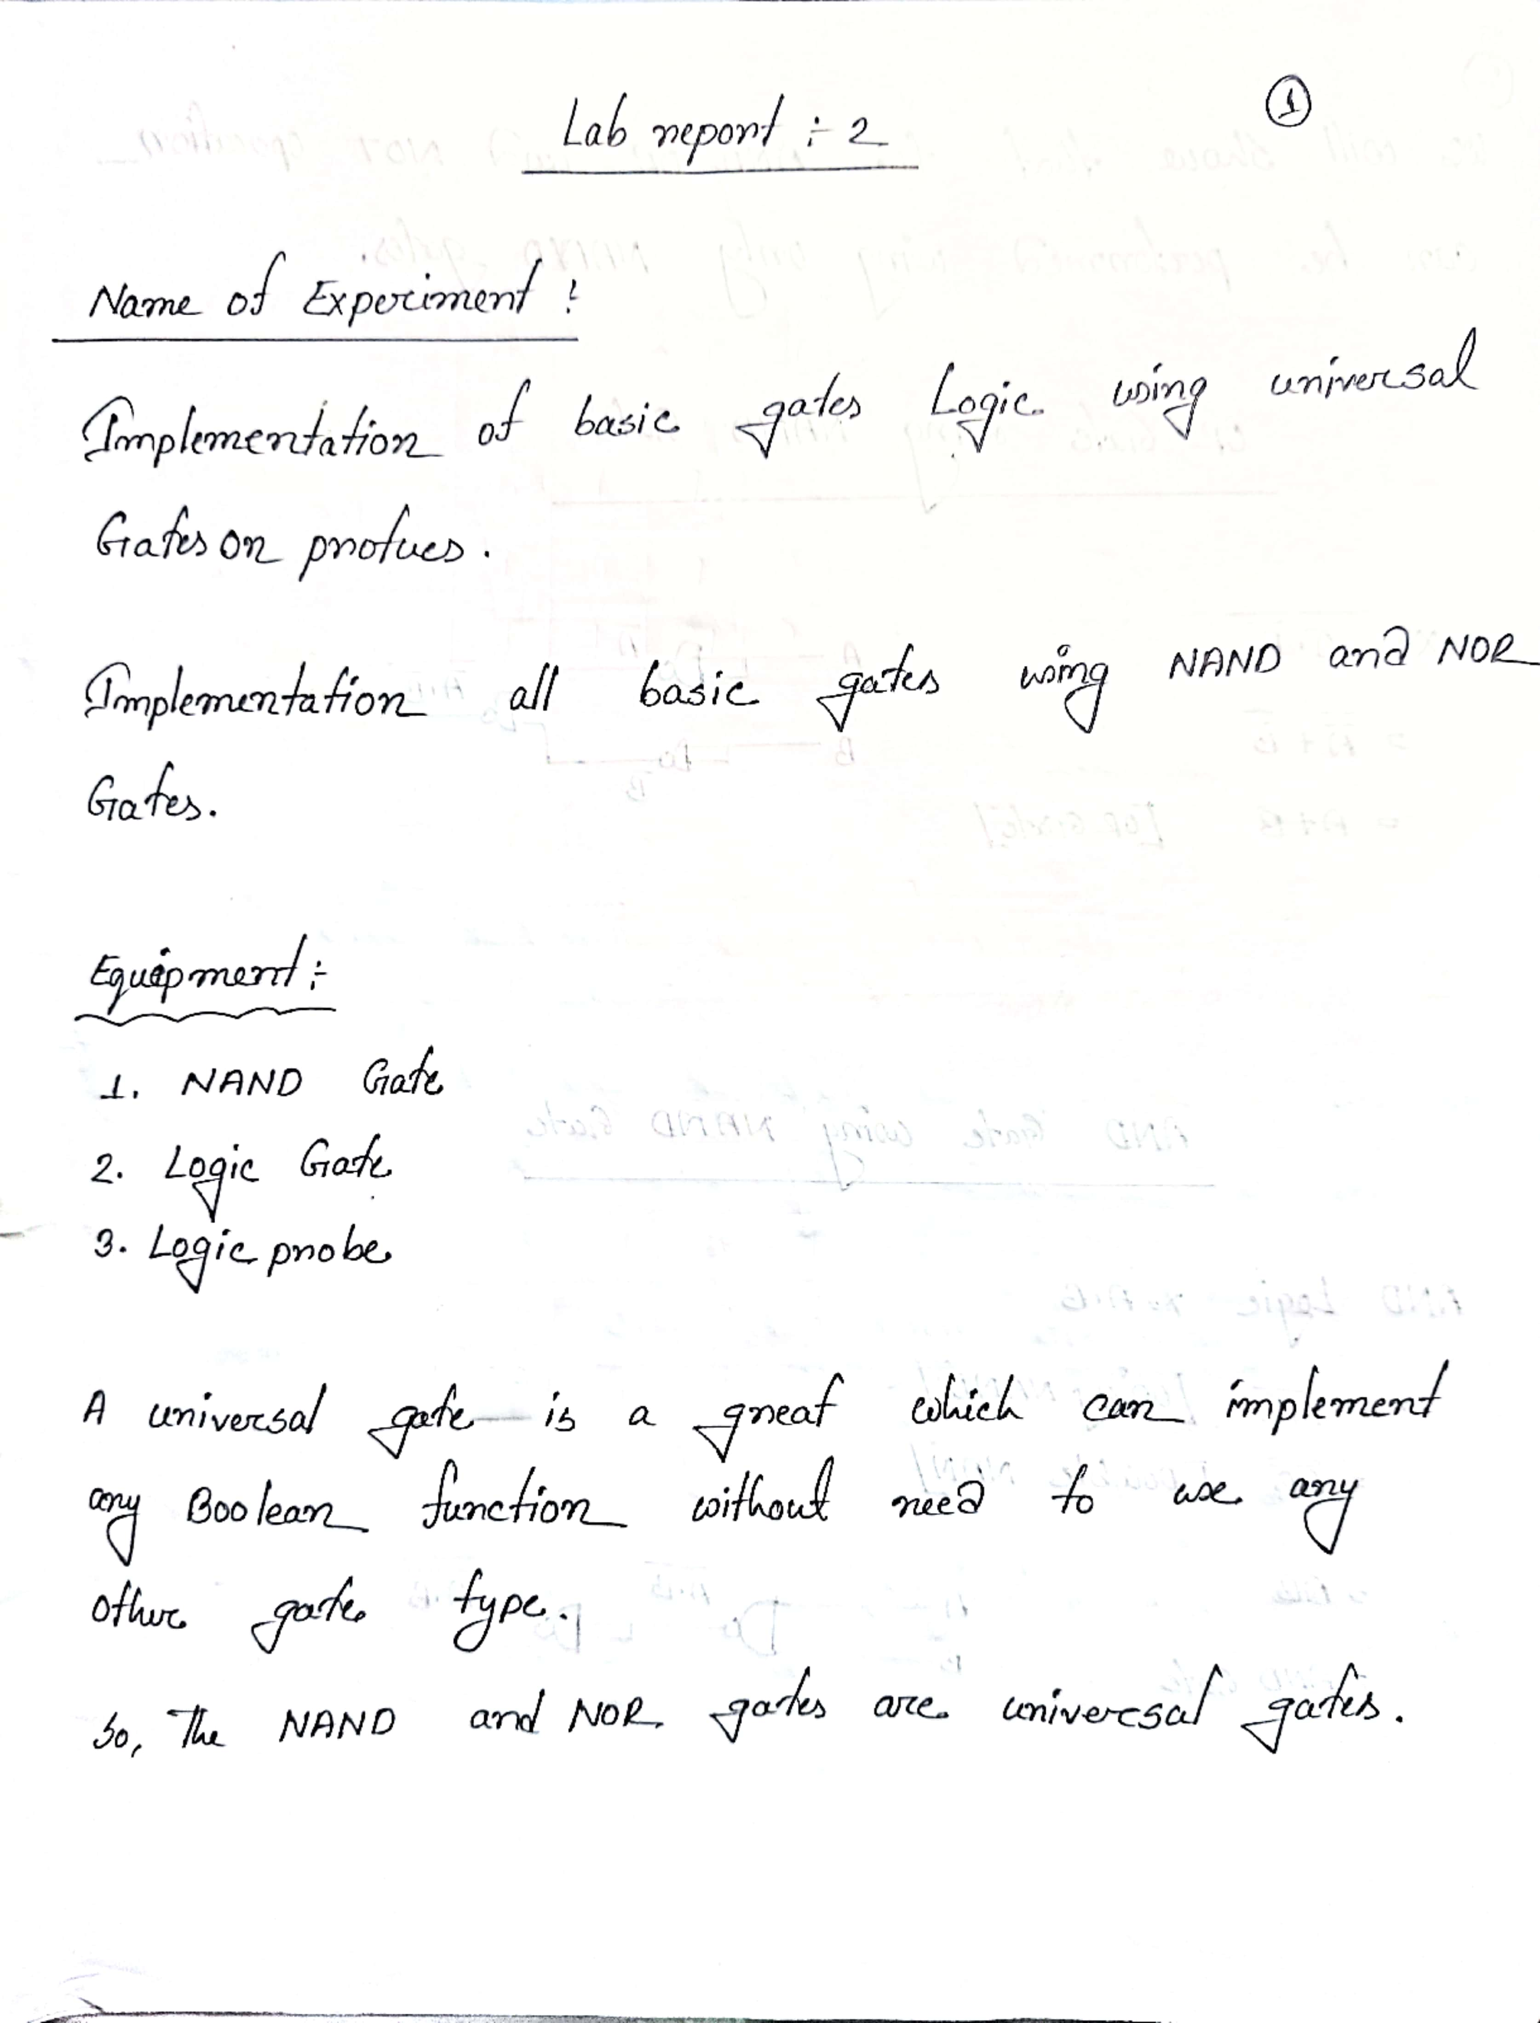

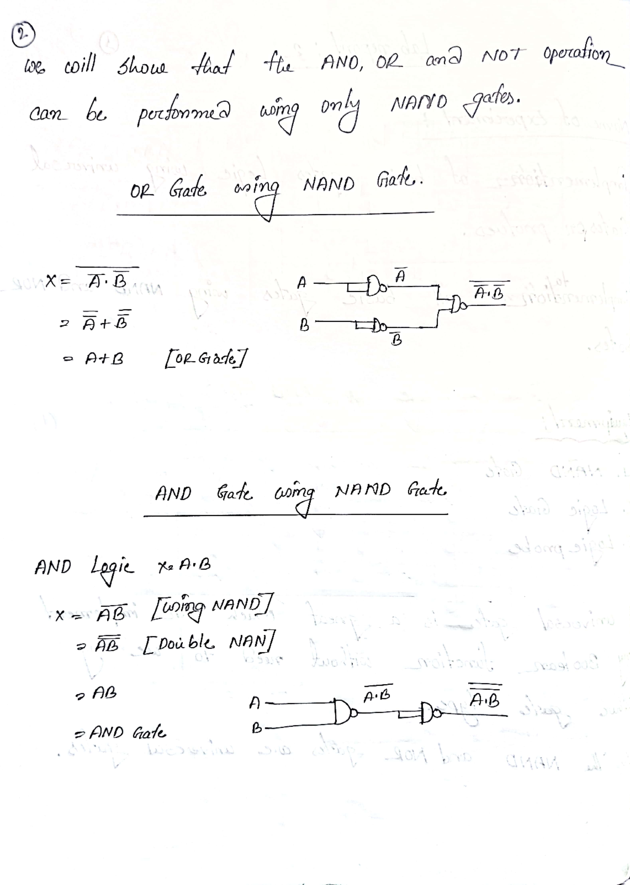

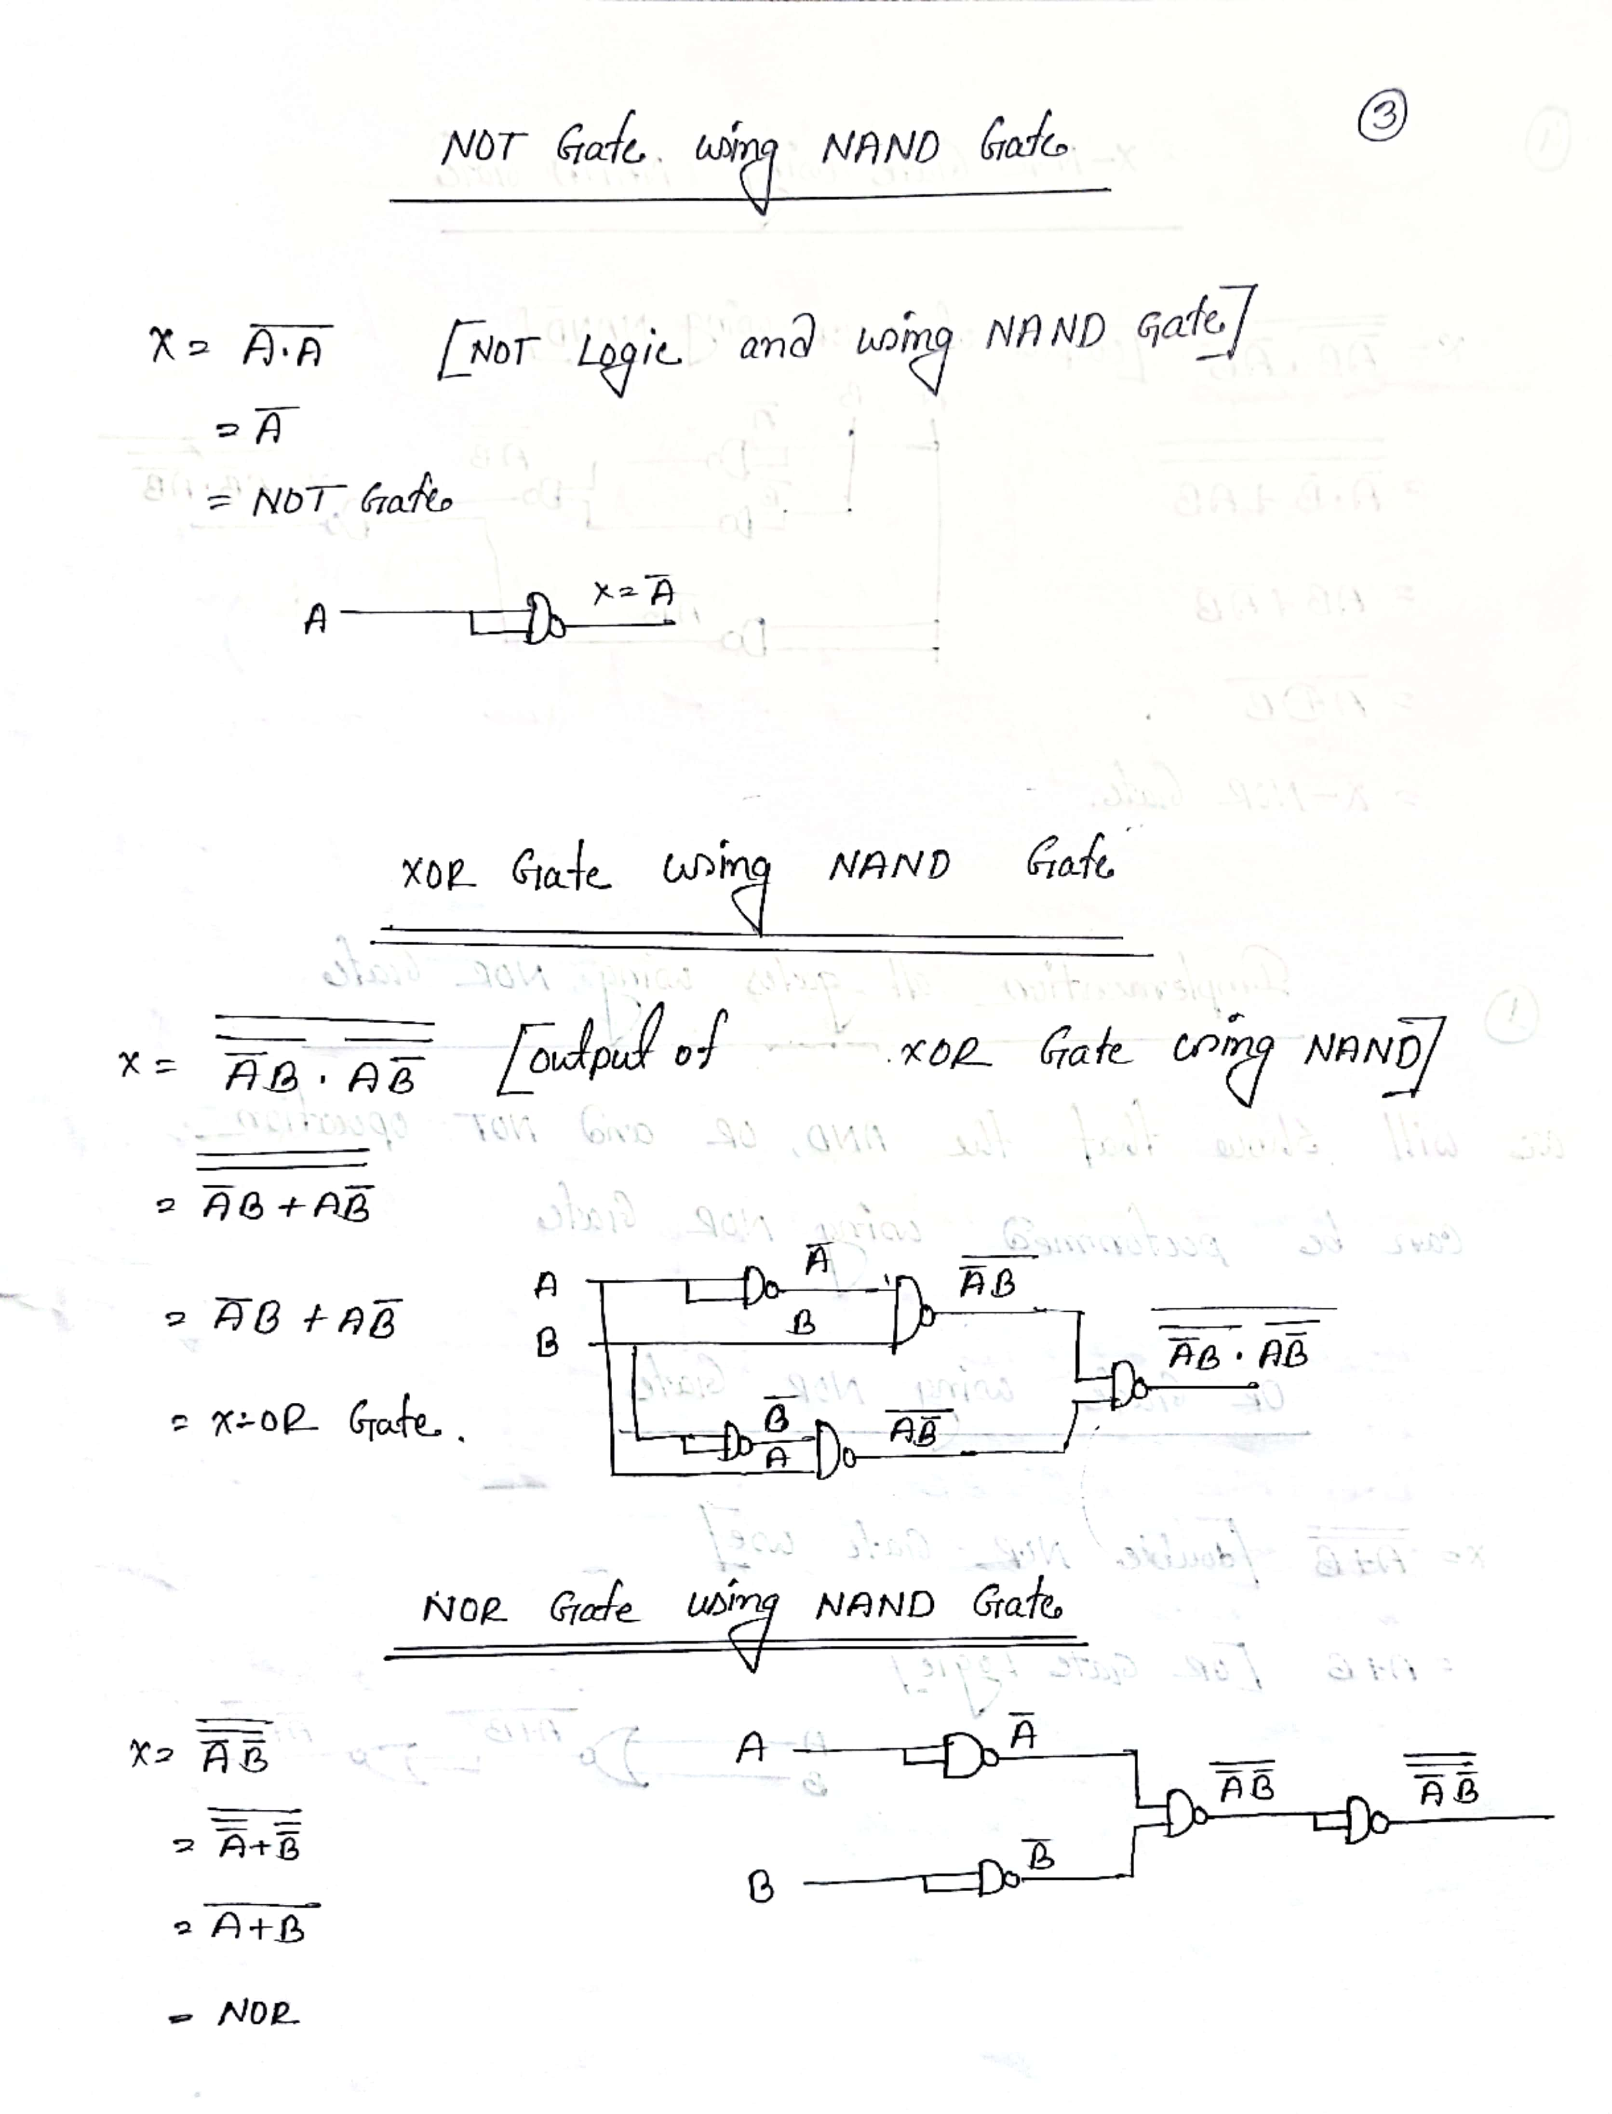

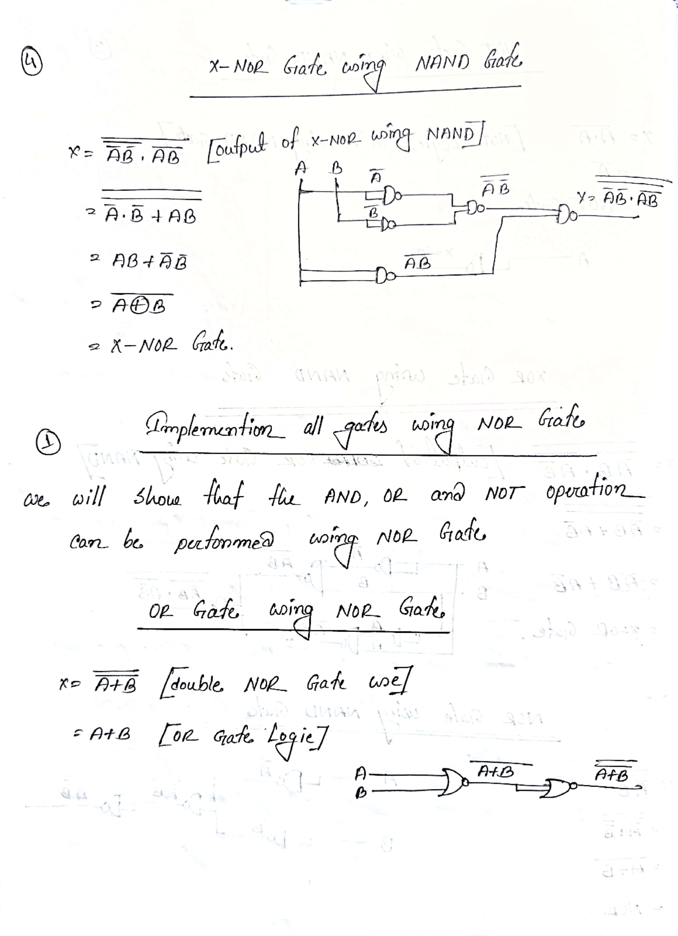

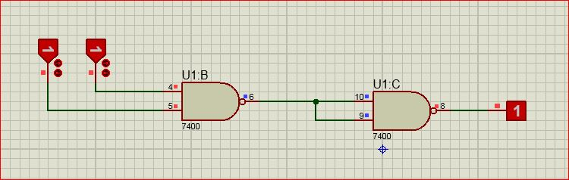 Picture of AND Gate Using NAND Gate

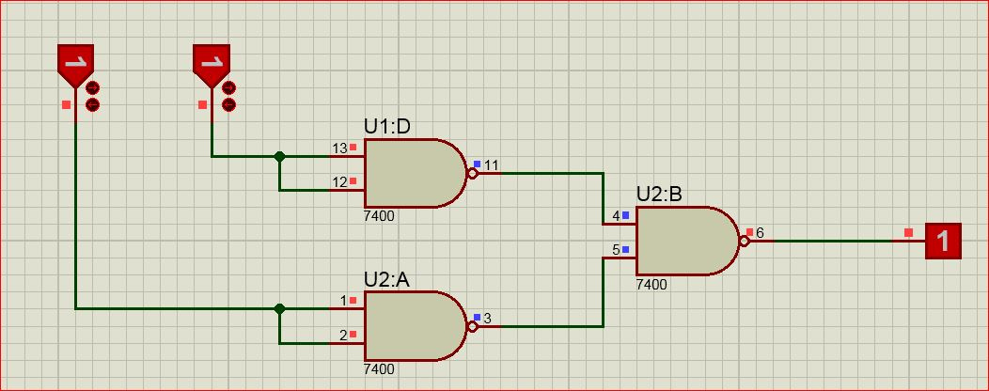

Picture of OR Gate Using NAND Gate

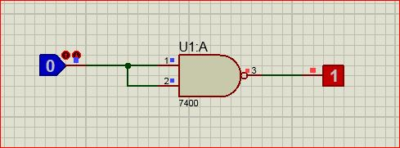

Picture of NOT Gate Using NAND Gate

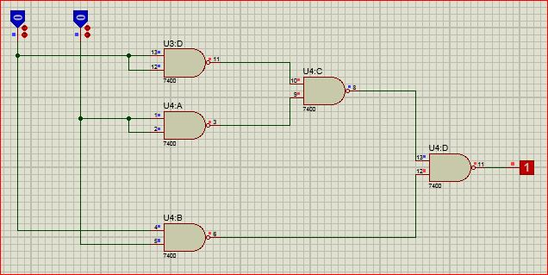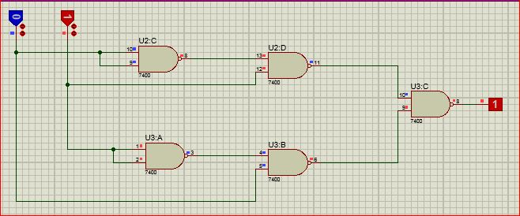 Picture of X-OR Gate Using NAND Gate

Picture of X-NOR Gate Using NAND Gate

Picture of NOR Gate Using NAND Gate 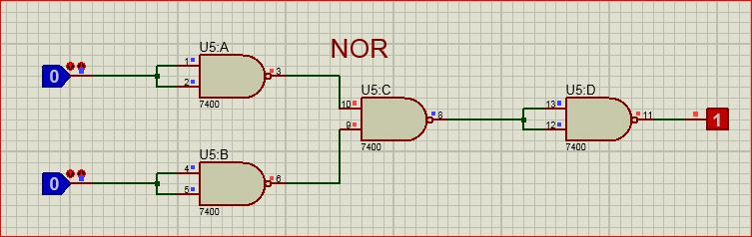



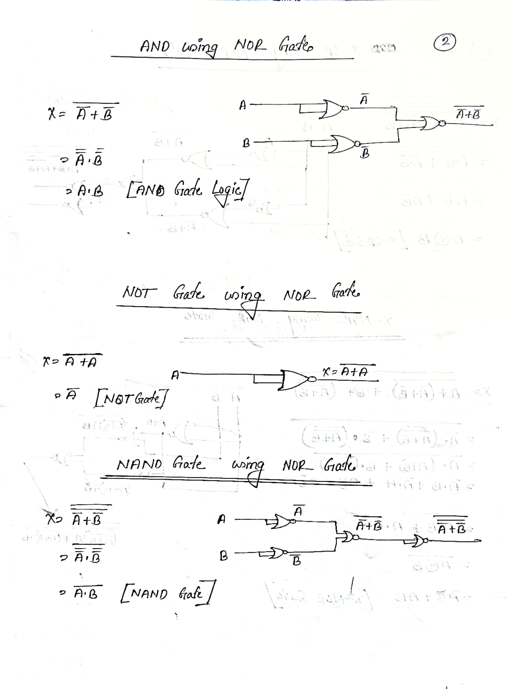

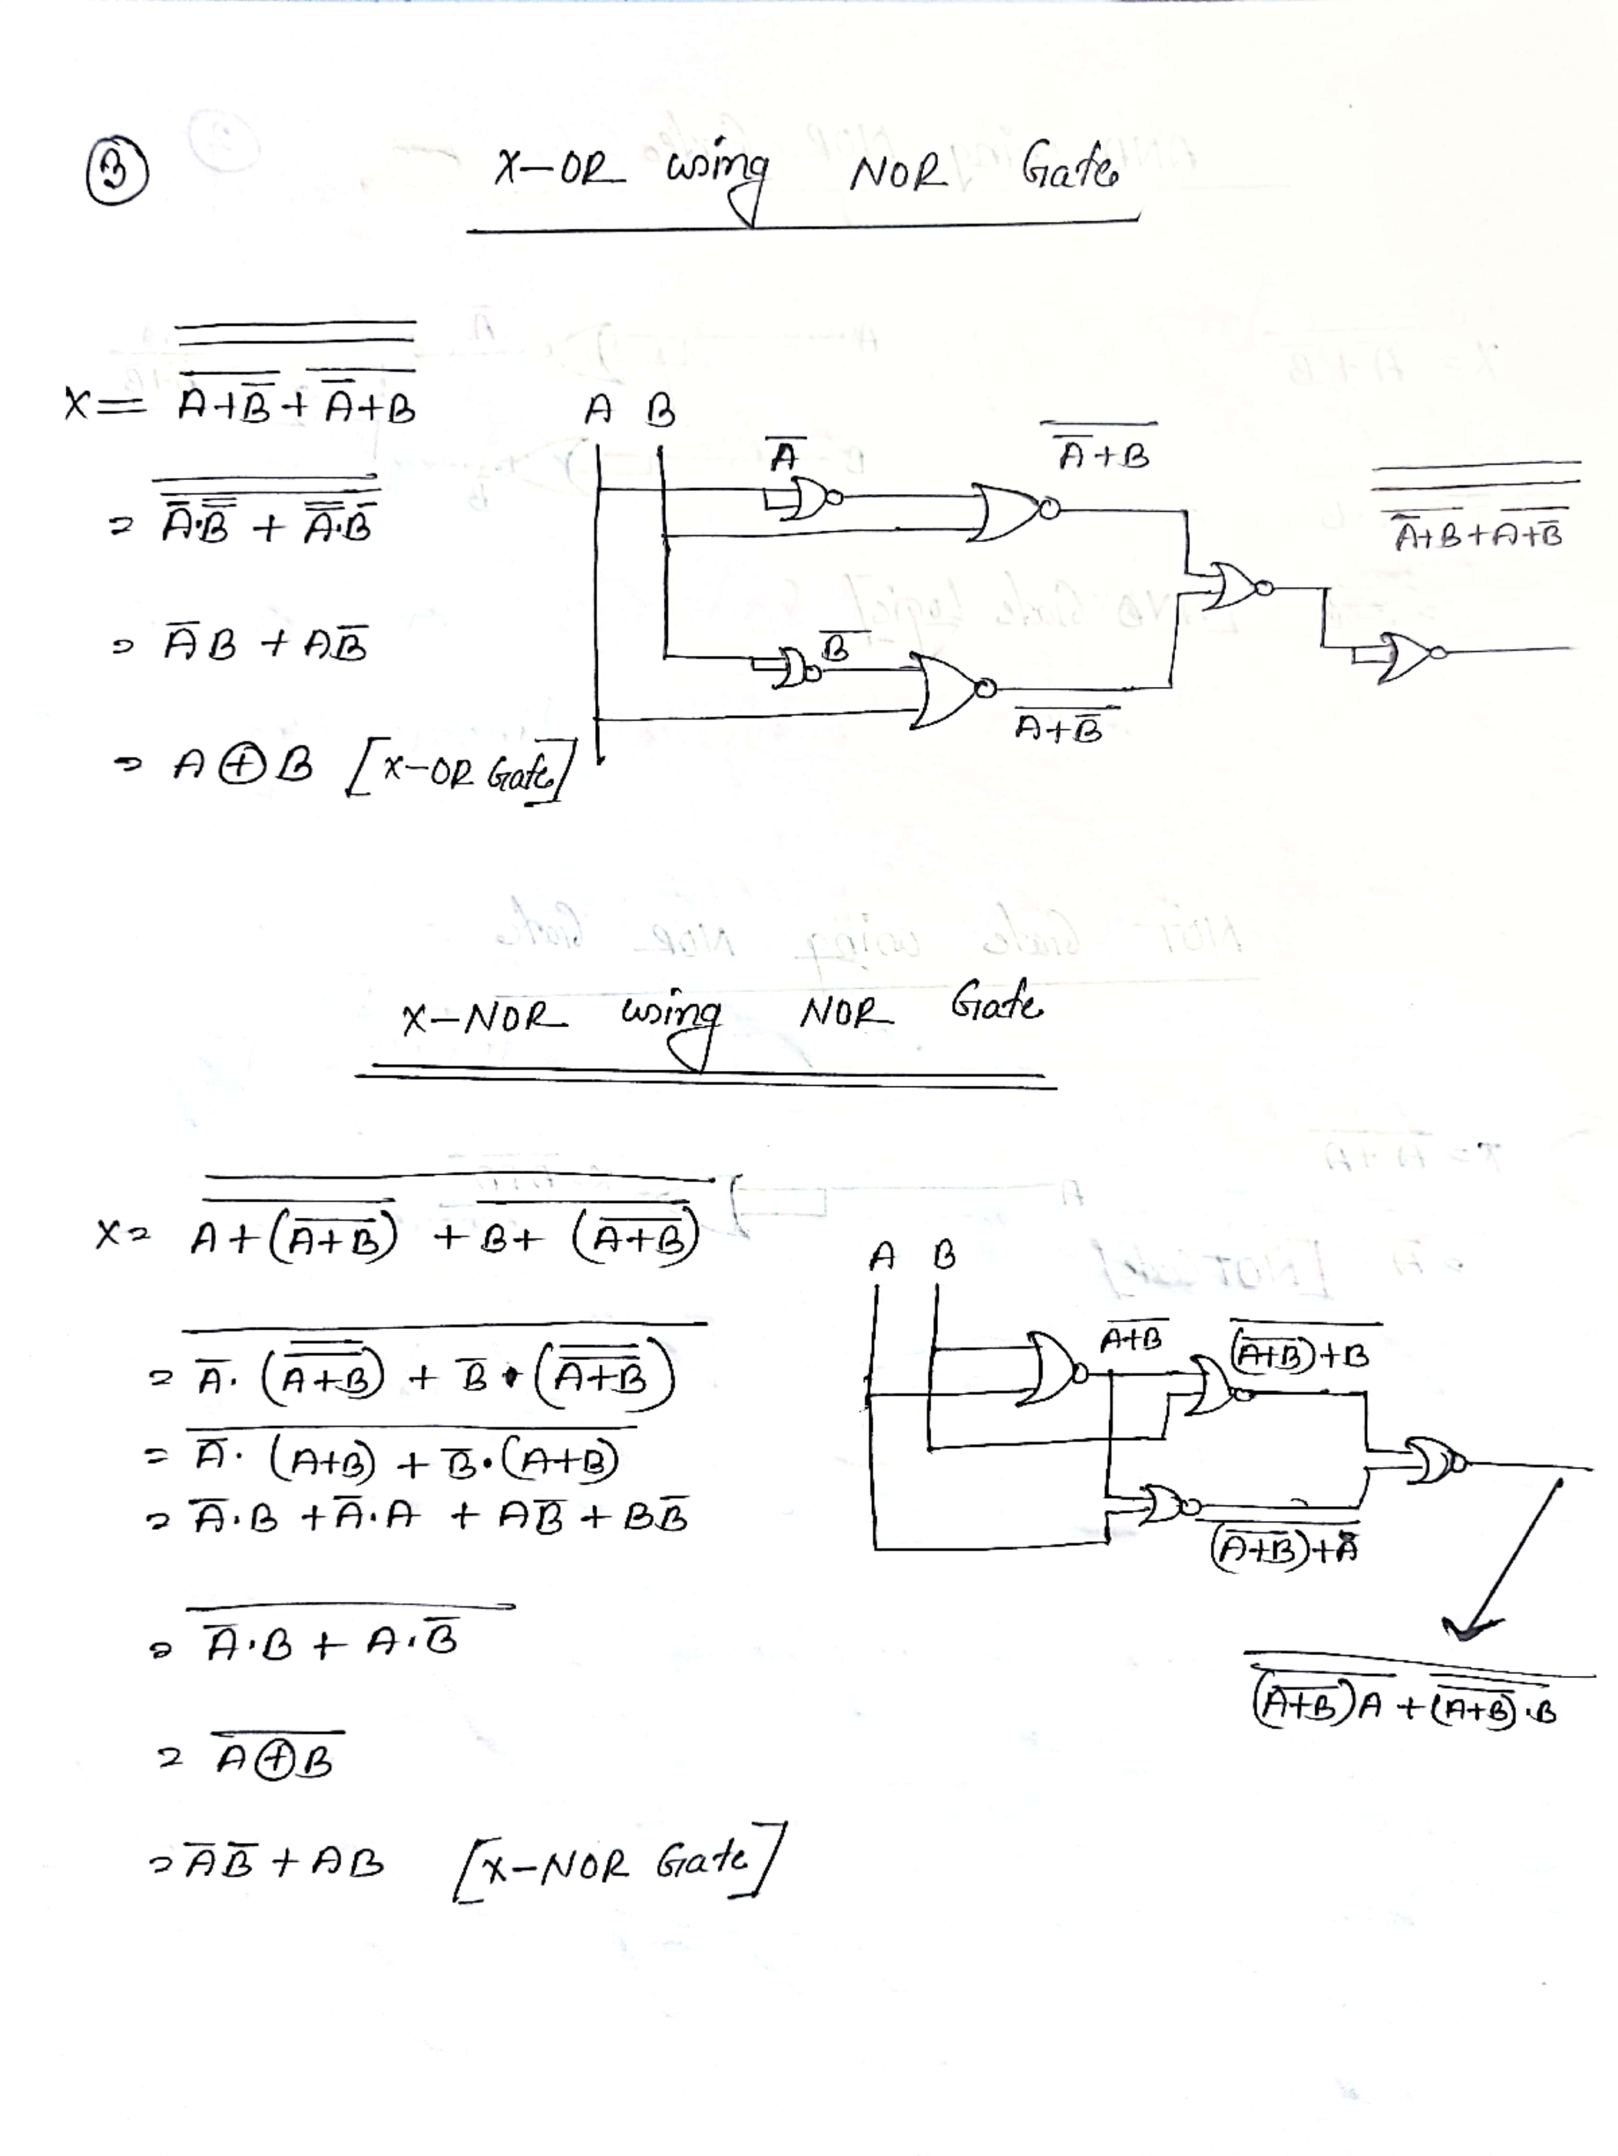

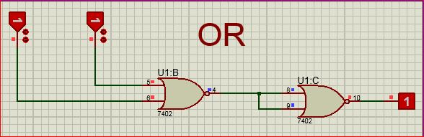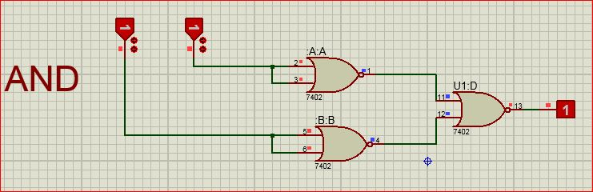 Picture of AND Gate Using NOR gate

Picture of OR Gate Using NOR gate

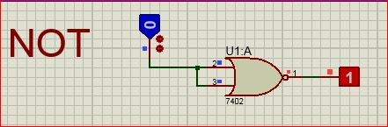

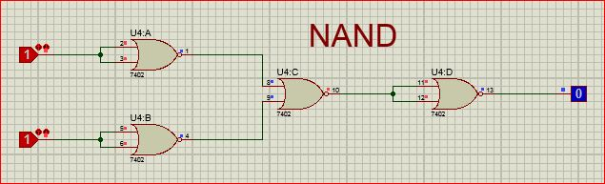 Picture of NOT Gate Using NOR gate

Picture of NOT Gate Using NOR gate

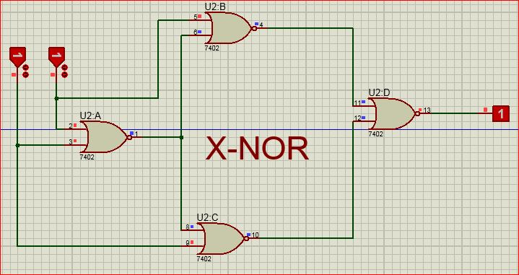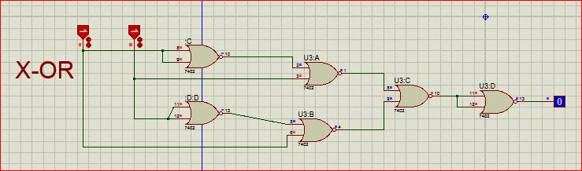 Picture of X-OR Gate Using NOR gate

Picture of X-NOR Gate Using NOR gate

